**Localization**

1. **What is localization?**

Localizing your application helps users work in their preferred language, which improves their experience and ensures a better understanding of the product. Pega applications can be configured to meet localization needs for work in different languages and time zones.

1. **How do you localize an application in pega?**

The process of localizing in an application can be visualized using the stages in a pega platform case life cycle.

1. **What are the stages in localizing an application?**

## Stage 1: Localization Design (App Design)

Ensure that you design and develop your application to support localization into multiple languages.

## Stage 2: Language Pack

Install the available language packs.

## Stage 3: Rulesets

Use the Localization wizard to translate application-specific rules.

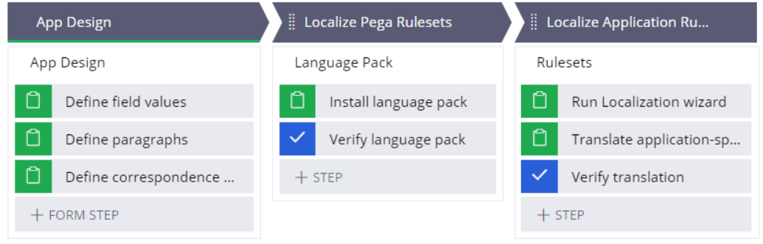

1. **Why do we use Localization Design?**

To design an application for localization, we create –

* **Field value rules –** for capturing labels and notes.
* **Paragraph rules –** for instructions and messages.
* **Correspondence rules –** for emails and other correspondence.

Once these elements are added to your application, they can be localized for most languages.

1. **What is the use of field value rules?**

Field value rules provide a way to localize words, phrases, and sentences in portals, reports, and user forms by managing the list of allowed values separately from the property.

This allows the same property to be reused and customized based on the context.

1. **What is the use of paragraph rules?**

Paragraph rules store long-form formatted text which can be reused throughout a user interface in various read-only contexts.

They are useful for making content such as instructions, copyright declarations and privacy notifications reusable, and are ideal for boilerplate content longer than 64 characters.

1. **Why do we use correspondence rules?**

Rules such as correspondence, paragraph, and work party rules contain text that is translated manually and stored in a ruleset with the help of the Localization wizard. This text is packaged and output into a Base.html and Translation.html file.

1. **What are language packs?**

Language packs are collections of language-specific rulesets that support the localization of Pega Platform.

1. **What is Language pack installation?**

Pega Platform provides language packs to localize the Pega rules (except the content on your UI forms). If language packs are available for your target languages, such as Spanish and Italian, install the language packs before you run the Localization wizard.

1. **What happens if language pack is not available?**

If a language pack is not available for one of your target languages, you can create your own custom translation pack. Use the Localization wizard to export and translate the Pega rulesets and content on your UI forms.

1. **What is Localization Wizard?**

The Localization wizard guides you through the process of translating the application.

1. **How do you configure the Localization?**

In Dev Studio, Click **Configure > User Interface > Application readiness >Localization.**

1. **What is meant by Translation pack?**

A Translation pack in pega refers to a set of language-specific resources and components that enable the localization or translation of a Pega application into different languages.

1. **Explain the process of localization wizard to translating application – specific rules?**

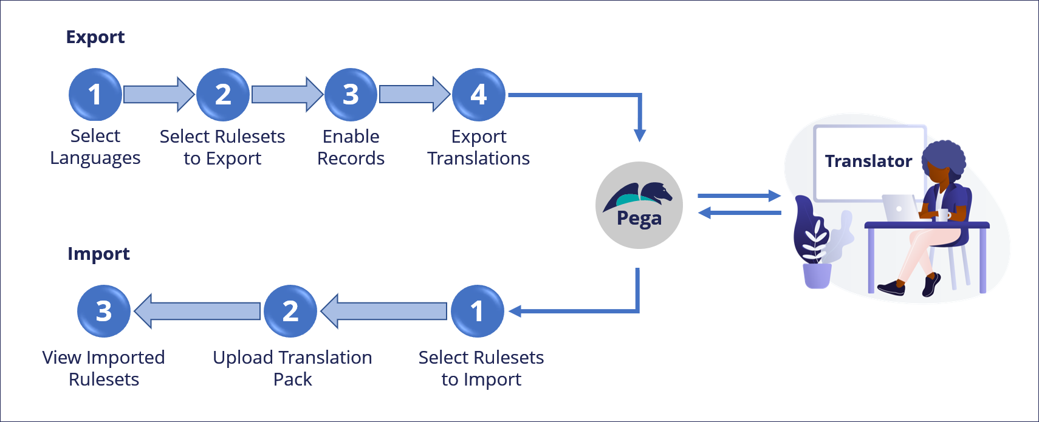

**Export:**

*1. Select Languages:* Specify the desired language; you can select more than one to create separate packages.

2. *Select Rulesets to Export:* Specify the unlocked application rulesets and versions that contain the rules to be translated.

3. *Enable Records:* If your original Pega Platform was from a version earlier than Pega 7, enable the localize settings for each record in the application unlocked ruleset to make the records ready for translation.

4. *Export Translation:* The application creates a compressed archive translation package for the selected languages.

**Import:**

*1. Select Rulesets to Import:* Specify the translation package along with the application ruleset to be translated.

2. *Upload Translation Pack*: Import the translated packages into the application.

3. *View Imported Rulesets*: View the translated rulesets.

1. **How to verify Localization?**

Set the**Locale**setting to a target language and run your application to verify that all labels, notes, instructions, messages, and emails are successfully localized. If any are missing, check the appropriate translation pack, add the missing translations, re-run the Localization wizard, and verify again. Verify that the language terms are displayed correctly when that language locale is selected.

The locale setting is available on the last screen of the Localization wizard.

In Dev Studio, click **Configure > User Interface > Application readiness > Localization.**

1. **What happens once rulesets are imported and tested?**

Once rulesets for all languages are imported and tested, Pega Platform automatically uses the ruleset based on the locale of the user. No further work is required to localize the application.

1. **Give some examples for Localization?**
2. Coca-Cola's “Share a Coke” campaign is a brilliant example of localization. Each coke bottle has a different name on its label. As part of the localization strategy, Coca-Cola adapted the campaign for local markets such as Ireland, China, and India. In the US, the bottles said Share a Coke with John or Sarah or Bobby. In Ireland, they chose Irish names like Aoife and Oisín.
3. If you have an app in English and want it to work in Spanish, you'd change all the text and labels to Spanish so Spanish-speaking users can use it easily.